**DATA IMPORTS** / **EXPORTS**

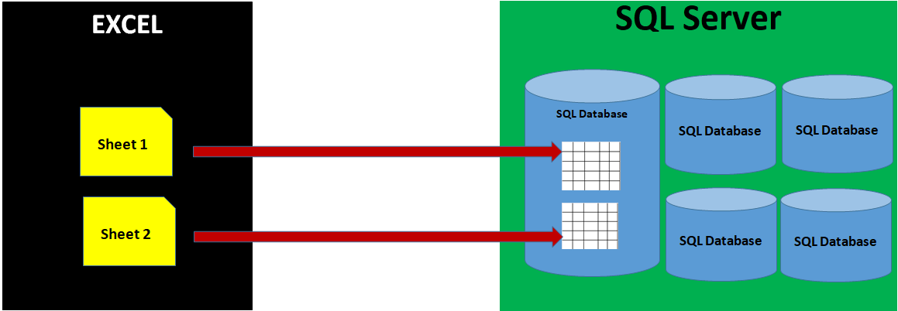

**HOW TO IMPORT DATA FROM EXCEL FILE TO SQL SERVER DATABASE TABLE ?**

Launch SSMS > Connect to SQL Server

Expand Databases Folder > Right Click the Database you created above > Tasks > **Import** > **Source**: Excel, Browse for the given Excel File > Next >

**Destination**: SQL Server Native Client, SQL Server Name and DB Name are auto filled >

Select Required Sheets > Table Names are auto filled >

Run Immediately > Finish.

To Test above Import Operation (**Bulk Operation**):

Expand Database > Expand Tables > Right Click above table > SELECT TOP 1000 Rows